PRO-C169

AR MARKER EVENTS

What is our GOAL for this MODULE?

We learned about marker events in augmented reality and also to structure the database

required for the AR menu card.

What did we ACHIEVE in the class TODAY?

● Learned to handle marker events in augmented reality web apps.

● Learned to structure the database for the menu card.

Which CONCEPTS/CODING BLOCKS did we cover today?

● AR.js marker creating tool.

● SweetAlert swal() function.

● <a-marker>,<a-entity> , <a-assets> tags.

● ngrok to run the application.

1. Write a component to handle markerFound and markerLost events in the AR scene.

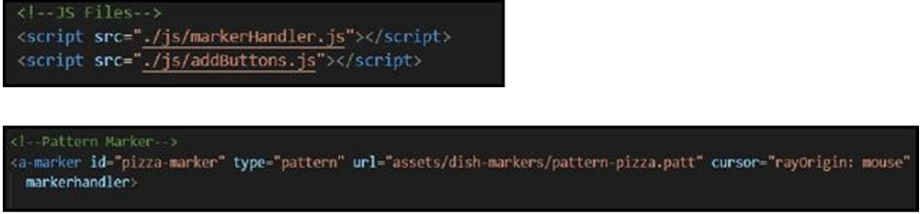

1. Update the button-div property of the button.

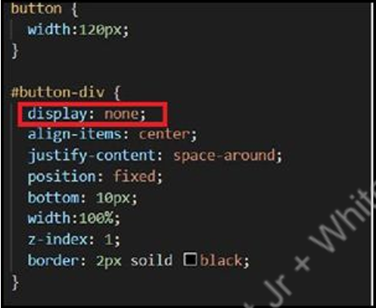

1. Write two functions to handle the marker events.

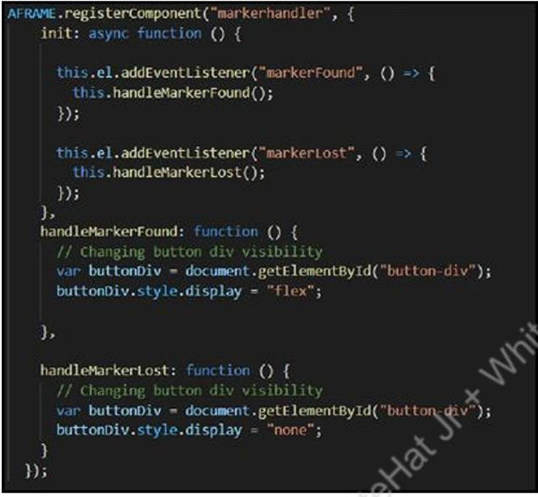

1. Add the library to add alert messages whenever the buttons are clicked.



1. Add the styling to the alert messages in .css file.

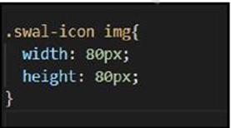

6. Add the alert messages in the handleMarkerFound() function on the button click:

● Use swal() function.

● Add icon, title, text as the options in the swal().

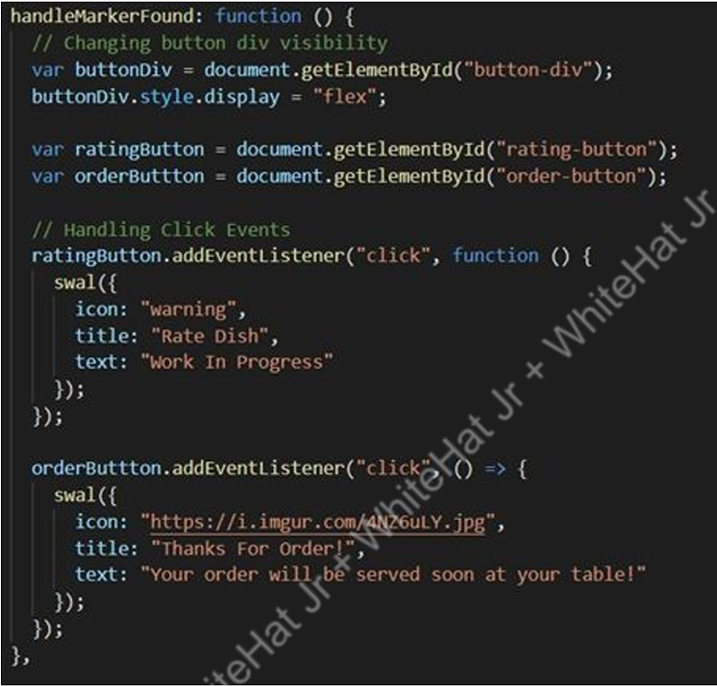

7 Add data fields as below.

● Add collection: dishes

● Add document: D01

● Add fields

■ dish_name: string

■ ingredients: array

■ marker_pattern_url: string

■ marker_image_url: string

■ model_geometry: map

● position: map

○ x: number

○ y: number

○ z: number

● rotation: map

○ x: number

○ y: number

○ z: number

● scale: map

○ x: number

○ y: number

○ z: number

■ model_url: string

What’s NEXT?

In the next class, we will learn about how we can connect A-Frame to the

Firebase database in Augmented Reality Web Apps.

EXTEND YOUR KNOWLEDGE:

● You can refer to the link below to explore more about A-Frame: A-Frame

● You can refer to the link below to explore more about AR.js: AR.js

● You can refer to the link below to explore more about SweetAlert: SweetAlert